CO4-Graph
A graph is a pictorial representation of a set of objects where some pairs of objects are connected by links. The interconnected objects are represented by points termed as vertices, and the links that connect the vertices are called edges.
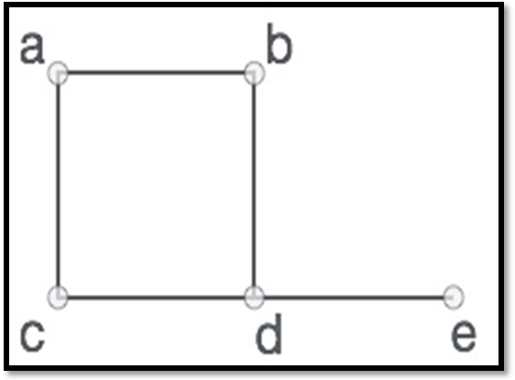
Formally, a graph is a pair of sets G = (V, E), where V is the set of vertices and E is the set of edges, connecting the pairs of vertices. Take a look at the following graph −
In the above graph,
V = {a, b, c, d, e}
E = {ab, ac, bd, cd, de}

Graph Data Structure
Mathematical graphs can be represented in data structure. We can represent a graph using an array of vertices and a two-dimensional array of edges. Before we proceed further, let's familiarize ourselves with some important terms –
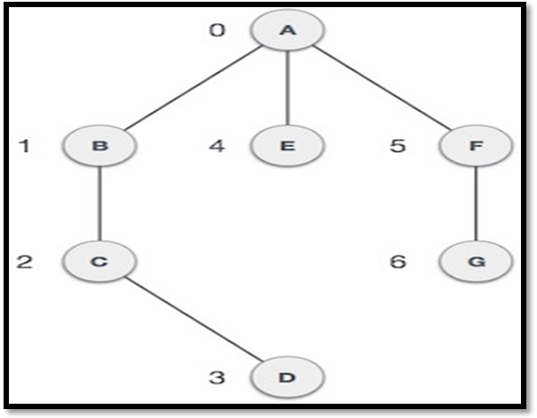
- Vertex − Each node of the graph is represented as a vertex. In the following example, the labeled circle represents vertices. Thus, A to G are vertices. We can represent them using an array as shown in the following image. Here A can be identified by index 0. B can be identified using index 1 and so on.
- Edge − Edge represents a path between two vertices or a line between two vertices. In the following example, the lines from A to B, B to C, and so on represents edges. We can use a two-dimensional array to represent an array as shown in the following image. Here AB can be represented as 1 at row 0, column 1, BC as 1 at row 1, column 2 and so on, keeping other combinations as 0.
- Adjacency − Two node or vertices are adjacent if they are connected to each other through an edge. In the following example, B is adjacent to A, C is adjacent to B, and so on.
- Path − Path represents a sequence of edges between the two vertices. In the following example, ABCD represents a path from A to D.

Basic Operations
Following are basic primary operations of a Graph −
- Add Vertex − Adds a vertex to the graph.
- Add Edge − Adds an edge between the two vertices of the graph.
- Display Vertex − Displays a vertex of the graph.
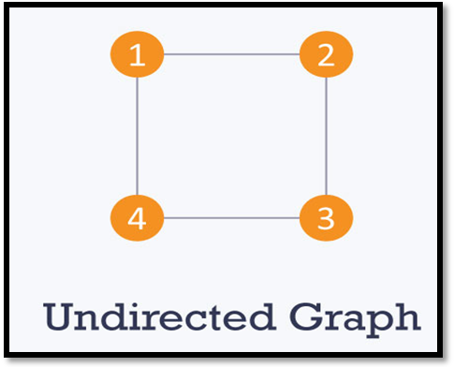
Types of graphs
Undirected Graph: An undirected graph is a graph in which all the edges are bi-directional i.e. the edges do not point in any specific direction.

Directed: A directed graph is a graph in which all the edges are uni-directional i.e. the edges point in a single direction.
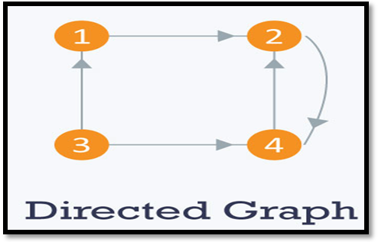
Weighted: In a weighted graph, each edge is assigned a weight or cost. Consider a graph of 4 nodes as in the diagram below. As you can see each edge has a weight/cost assigned to it. If you want to go from vertex 1 to vertex 3, you can take one of the following 3 paths:
- 1 -> 2 -> 3
- 1 -> 3
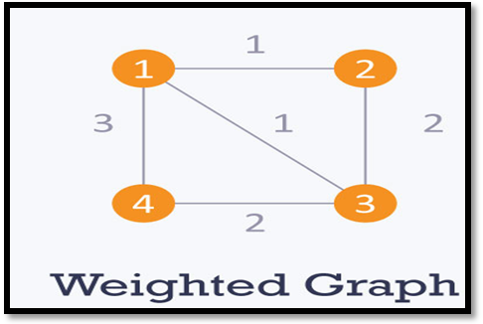
- 1 -> 4 -> 3
Therefore the total cost of each path will be as follows: - The total cost of 1 -> 2 -> 3 will be (1 + 2) i.e. 3 units - The total cost of 1 -> 3 will be 1 unit - The total cost of 1 -> 4 -> 3 will be (3 + 2) i.e. 5 units
Cyclic: A graph is cyclic if the graph comprises a path that starts from a vertex and ends at the same vertex. That path is called a cycle. An acyclic graph is a graph that has no cycle

Directed Acyclic Graph (DAG) : A directed acyclic graph (DAG) is a graph that is directed and without cycles connecting the other edges. This means that it is impossible to traverse the entire graph starting at one edge. The edges of the directed graph only go one way. The graph is a topological sorting, where each node is in a certain order.

Graph and its representations
Graph is a data structure that consists of following two components:
1. A finite set of vertices also called as nodes.
2. A finite set of ordered pair of the form (u, v) called as edge. The pair is ordered because (u, v) is not same as (v, u) in case of a directed graph (di-graph). The pair of the form (u, v) indicates that there is an edge from vertex u to vertex v. The edges may contain weight/value/cost.
Graphs are used to represent many real-life applications: Graphs are used to represent networks. The networks may include paths in a city or telephone network or circuit network. Graphs are also used in social networks like linkedIn, Facebook. For example, in Facebook, each person is represented with a vertex(or node). Each node is a structure and contains information like person id, name, gender and locale.
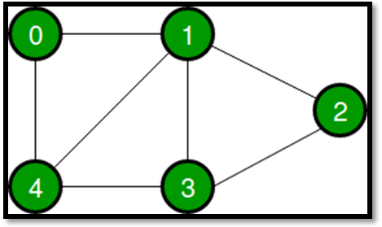
Following two are the most commonly used representations of a graph.
1. Adjacency Matrix
2. Adjacency List
There are other representations also like, Incidence Matrix and Incidence List. The choice of the graph representation is situation specific. It totally depends on the type of operations to be performed and ease of use.
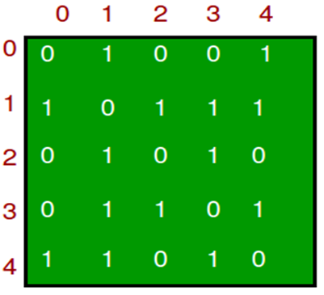
Adjacency Matrix:
Adjacency Matrix is a 2D array of size V x V where V is the number of vertices in a graph. Let the 2D array be adj[][], a slot adj[i][j] = 1 indicates that there is an edge from vertex i to vertex j. Adjacency matrix for undirected graph is always symmetric. Adjacency Matrix is also used to represent weighted graphs. If adj[i][j] = w, then there is an edge from vertex i to vertex j with weight w.
The adjacency matrix for the above example graph is:
Pros: Representation is easier to implement and follow. Removing an edge takes O(1) time. Queries like whether there is an edge from vertex ‘u’ to vertex ‘v’ are efficient and can be done O(1).
Cons: Consumes more space O(V^2). Even if the graph is sparse(contains less number of edges), it consumes the same space. Adding a vertex is O(V^2) time.
Please see this for a sample Python implementation of adjacency matrix.
Adjacency List
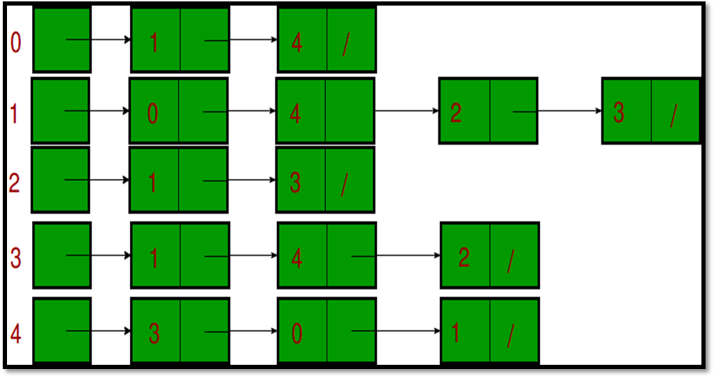
An array of lists is used. Size of the array is equal to the number of vertices. Let the array be array []. An entry array[i] represents the list of vertices adjacent to the ith vertex. This representation can also be used to represent a weighted graph. The weights of edges can be represented as lists of pairs. Following is adjacency list representation of the above graph.

Topological Sorting
Topological sorting for Directed Acyclic Graph (DAG) is a linear ordering of vertices such that for every directed edge uv, vertex u comes before v in the ordering. Topological Sorting for a graph is not possible if the graph is not a DAG. The arrangement is totally depend on in-degree of each vertex.
In a Directed acyclic graph many a times we can have vertices which are unrelated to each other because of which we can order them in many ways. These various topological sorting is important in many cases, for example if some relative weight is also available between the vertices, which is to minimize then we need to take care of relative ordering as well as their relative weight, which creates the need of checking through all possible topological ordering.
We can go through all possible ordering via backtracking, the algorithm step are as follows:
- Initialize all vertices as unvisited.
- Now choose vertex which is unvisited and has zero indegree and decrease indegree of all those vertices by 1 (corresponding to removing edges) now add this vertex to result and call the recursive function again and backtrack.
- After returning from function reset values of visited, result and indegree for enumeration of other possibilities.

Applications of Topological Sort
Few important applications of topological sort are-
- Scheduling jobs from the given dependencies among jobs
- Instruction Scheduling
- Determining the order of compilation tasks to perform in make files
- Data Serialization

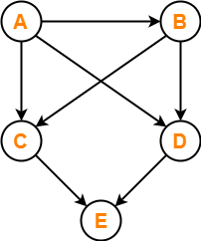
Problem-01: Find the number of different topological orderings possible for the given graph-
Solution:
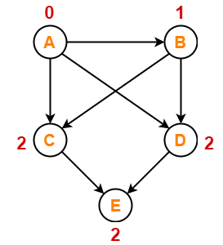
The topological orderings of the above graph are found in the following steps-
Step-01:
Write in-degree of each vertex.

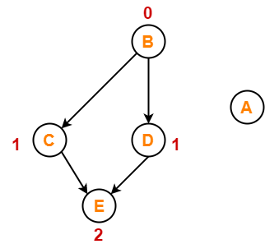
Step-02:
- Vertex-A has the least in-degree.
- So, remove vertex-A and its associated edges.
- Now, update the in-degree of other vertices.

Step-03:

- Vertex-B has the least in-degree.
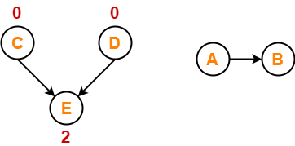
- So, remove vertex-B and its associated edges.
- Now, update the in-degree of other vertices.

Step-04:
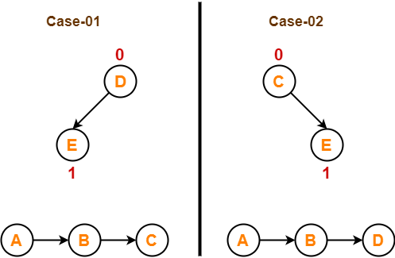
There are two vertices with the least in-degree. So, following 2 cases are possible-
In case-01,
- Remove vertex-C and its associated edges.
- Then, update the in-degree of other vertices.
In case-02,
- Remove vertex-D and its associated edges.
- Then, update the in-degree of other vertices.

Step-05:
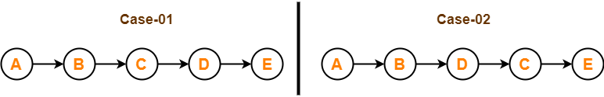
Now, the above two cases are continued separately in the similar manner.
In case-01,
- Remove vertex-D since it has the least in-degree.
- Then, remove the remaining vertex-E.
In case-02,
- Remove vertex-C since it has the least in-degree.
- Then, remove the remaining vertex-E.

Conclusion :For the given graph, following 2 different topological orderings are possible-
- A B C D E
- A B D C E
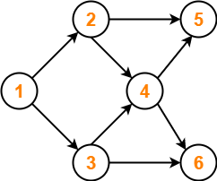
Problem-02:Find the number of different topological orderings possible for the given graph
Solution

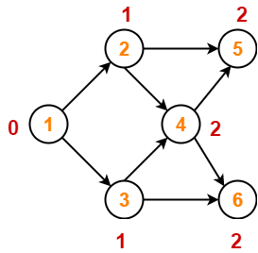
The topological orderings of the above graph are found in the following steps-

Step-01:
Write in-degree of each vertex.

Step-02:
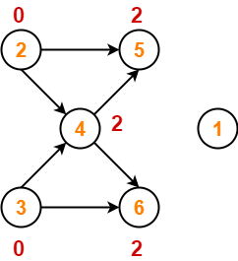
- Vertex-1 has the least in-degree.
- So, remove vertex-1 and its associated edges.
- Now, update the in-degree of other vertices.

Step-03:
There are two vertices with the least in-degree. So, following 2 cases are possible-
In case-01,
- Remove vertex-2 and its associated edges.
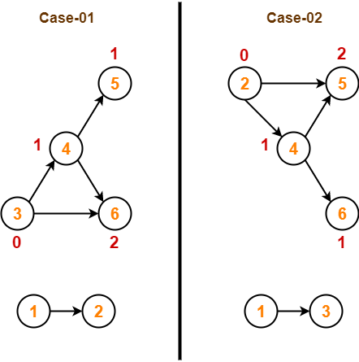
- Then, update the in-degree of other vertices.
In case-02,
- Remove vertex-3 and its associated edges.
- Then, update the in-degree of other vertices.

Step-04:
Now, the above two cases are continued separately in the similar manner.
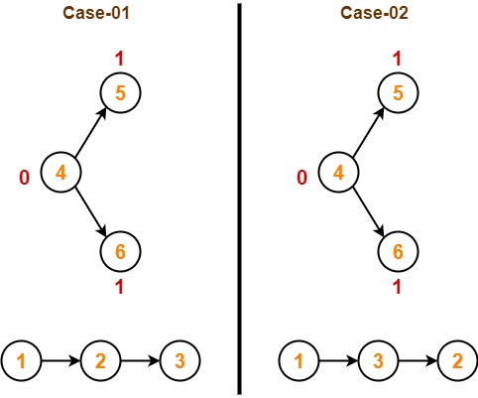
In case-01,
- Remove vertex-3 since it has the least in-degree.
- Then, update the in-degree of other vertices.
In case-02,
- Remove vertex-2 since it has the least in-degree.
- Then, update the in-degree of other vertices.

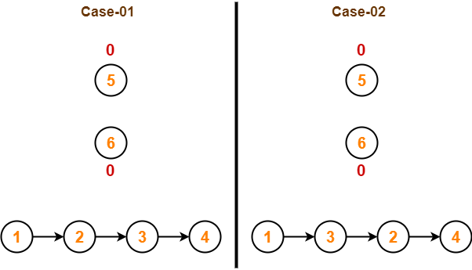
Step-05:
In case-01,
- Remove vertex-4 since it has the least in-degree.
- Then, update the in-degree of other vertices.
In case-02,
- Remove vertex-4 since it has the least in-degree.
- Then, update the in-degree of other vertices.
Step-06:
In case-01,
- There are 2 vertices with the least in-degree.
- So, 2 cases are possible.
- Any of the two vertices may be taken first.
Same is with case-02.
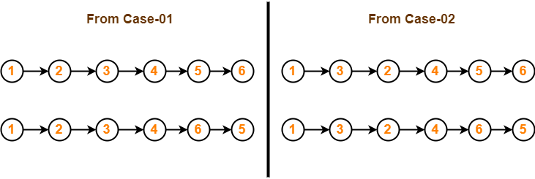
Conclusion-
For the given graph, following 4 different topological orderings are possible-
- 1 2 3 4 5 6
- 1 2 3 4 6 5
- 1 3 2 4 5 6
- 1 3 2 4 6 5
Problem-03:
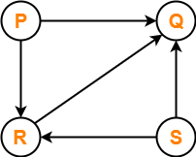
Consider the directed graph given below. Which of the following statements is true?

- The graph does not have any topological ordering.
- Both PQRS and SRPQ are topological orderings.
- Both PSRQ and SPRQ are topological orderings.
- PSRQ is the only topological ordering.

Solution-

- The given graph is a directed acyclic graph.
- So, topological orderings exist.
- P and S must appear before R and Q in topological orderings as per the definition of topological sort.

Thus, Correct option is (C).
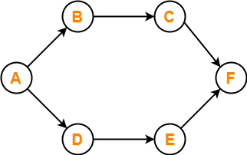

Problem-04:

Consider the following directed graph-

The number of different topological orderings of the vertices of the graph is ________ ?

Solution-

Number of different topological orderings possible = 6.
Thus, Correct answer is 6.

Problem-05:
For example, consider the below graph.

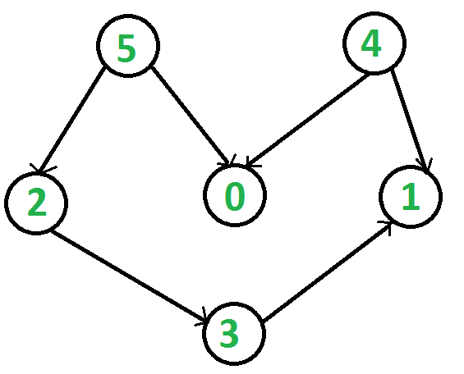

All topological sorts of the given graph are:
4 5 0 2 3 1
4 5 2 0 3 1
4 5 2 3 0 1
4 5 2 3 1 0
5 2 3 4 0 1
5 2 3 4 1 0
5 2 4 0 3 1
5 2 4 3 0 1
5 2 4 3 1 0
5 4 0 2 3 1
5 4 2 0 3 1
5 4 2 3 0 1
5 4 2 3 1 0

Below is implementation of above steps.
/Java program to print all topolgical sorts of a graph
import java.util.*;

class Graph {
int V; // No. of vertices

List<Integer> adjListArray[];

public Graph(int V) {

this.V = V;

@SuppressWarnings("unchecked")
List<Integer> adjListArray[] = new LinkedList[V];

this.adjListArray = adjListArray;

for (int i = 0; i < V; i++) {
adjListArray[i] = new LinkedList<>();
}
}
// Utility function to add edge
public void addEdge(int src, int dest) {

this.adjListArray[src].add(dest);

}

// Main recursive function to print all possible
// topological sorts
private void allTopologicalSortsUtil(boolean[] visited,
int[] indegree, ArrayList<Integer> stack) {
// To indicate whether all topological are found
// or not
boolean flag = false;

for (int i = 0; i < this.V; i++) {
// If indegree is 0 and not yet visited then
// only choose that vertex
if (!visited[i] && indegree[i] == 0) {

// including in result
visited[i] = true;
stack.add(i);
for (int adjacent : this.adjListArray[i]) {
indegree[adjacent]--;
}
allTopologicalSortsUtil(visited, indegree, stack);

// resetting visited, res and indegree for
// backtracking
visited[i] = false;
stack.remove(stack.size() - 1);
for (int adjacent : this.adjListArray[i]) {
indegree[adjacent]++;
}

flag = true;
}
}
// We reach here if all vertices are visited.
// So we print the solution here
if (!flag) {
stack.forEach(i -> System.out.print(i + " "));
System.out.println();
}

}

// The function does all Topological Sort.
// It uses recursive alltopologicalSortUtil()
public void allTopologicalSorts() {
// Mark all the vertices as not visited
boolean[] visited = new boolean[this.V];

int[] indegree = new int[this.V];

for (int i = 0; i < this.V; i++) {

for (int var : this.adjListArray[i]) {
indegree[var]++;
}
}

ArrayList<Integer> stack = new ArrayList<>();

allTopologicalSortsUtil(visited, indegree, stack);
}

// Driver code
public static void main(String[] args) {
// Create a graph given in the above diagram
Graph graph = new Graph(6);
graph.addEdge(5, 2);
graph.addEdge(5, 0);
graph.addEdge(4, 0);
graph.addEdge(4, 1);
graph.addEdge(2, 3);
graph.addEdge(3, 1);
System.out.println("All Topological sorts");
graph.allTopologicalSorts();
}
}

